Circuit Analysis (Lab3)
Experiment 3: Introduction to Multimeter and Basic Series Circuit Implementation

Name: TALHA YOUSAF Registration No: 2025-CE-93
Date 31-3-2026 Grade and Signature: ………………………..
CLO2  CLO3 | Use with identification the circuit components, breadboards, multimeters, power supplies, signal generators, and oscilloscopes.  Make measurements in their own constructed electric circuits.
Psychomotor/Affective | Level1  (1) | Level2  (2-3) | Level3  (4-5) | Level4  (6-7)
Report Marks (3) |  |  | Total marks (10)

Objectives: To get understanding of how to use a multimeter and make measurements in your own constructed series circuits.
Equipment required:
Power Supply, Breadboard, Connecting wires, Resistances, Multimeter.

What is a multimeter?
A multimeter is a measurement tool necessary in electronics. It combines three essential features: a voltmeter, ohmmeter, and ammeter, and in some cases continuity. A multimeter allows you to understand what is going on in your circuits. Whenever something in your circuit isn’t working, the multimeter will help you troubleshooting.

Parts of Multimeter:
Display: this is where the measurements are displayed Selection knob: this selects what you want to measure Ports: this is where you plug in the probes
Probes: a multimeter comes with two probes. Generally, one is red and the other is black.
Note: There isn’t any difference between the red and the black probes, just the color. So, assuming the convention:
- The black probe is always connected to the COM port.
- The red probe is connected to one of the other ports depending on what you want to measure.

Ports
The “COM” or “–“ port is where the black probe should be connected. The COM probe is conventionally black.
- A is used when measuring large currents, greater than 200mA
- mA is used to measure current
- VΩ allows you to measure voltage and resistance and test continuity.

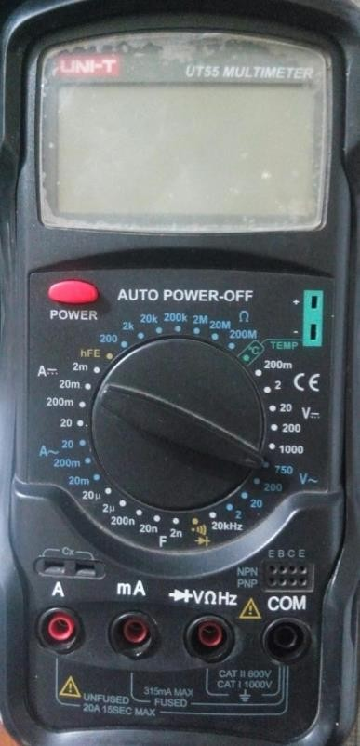

Figure 1 Digital Multimeter (DMM)

Introduction to resistance measurements
Resistance is measured with the circuit’s power turned off. The ohmmeter sends its own current through the unknown resistance and then measures that current to provide a resistance value readout.

Resistance measurement procedures
Follow the steps below to measure resistance:
- Turn off the power to the circuit. Remove or isolate the component to be tested.
- Plug the test probes into the appropriate probe jacks. Note that the jacks used may be the same ones used to measure volts.
- Select the ohms function by turning the function switch to ohms. Start with the lowest setting.
- Touch the probes together to check the leads, connections and battery life. The meter should display zero or a very small amount of resistance for the test leads. With the leads apart, the meter should display OL or I, depending on the manufacturer.
- Connect the tips of the probes across the break in the component or portion of the circuit for which you want to determine resistance. If you get an OL (over limit), move to the next level.
- View the reading on the display unit. Be sure to note the unit of measurement.
- After all the resistance readings are complete, turn the DMM off to prevent the battery from draining

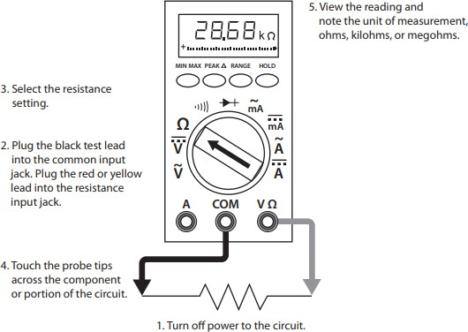
Figure 2 Using a DMM to measure resistance

Introduction to voltage measurements

Voltage measurements are very easy to make with a DMM. On meters with manual range selection, start with a value one setting higher than expected. An auto range DMM will automatically select the range based on the voltage present. Figure 4 shows the process.

Note:

1/ 1000 V=1mV

1000 V=1kV

Follow these steps to measure voltage:

- Select the DC or AC volts function by turning the function switch to DC or AC volts.
- Plug the test probes into the appropriate probe jacks.
- Connect the tips of the probes across the source or load.
- View the reading on the display unit. Be sure to note the unit of measurement. If you are testing DC voltage and a negative sign appears in the display, the polarity of your probes is incorrect and needs to be reversed.

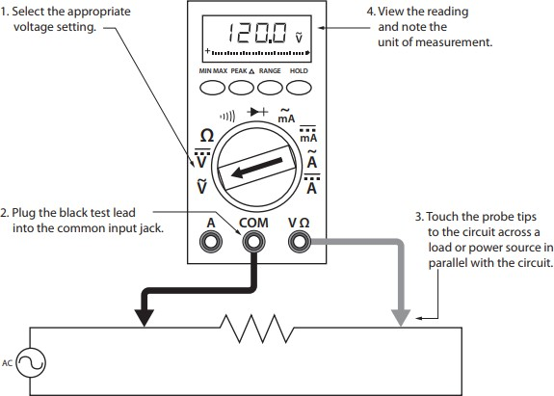

Figure 3 Using a DMM to measure voltage

Introduction to current measurements

As you have seen, the placement of meter leads for voltage measurements is straightforward. The leads are simply connected across, or in parallel with, the points of voltage to be measured. For current measurements, however, the process is slightly more complex.
First, the circuit must be opened at the test points and the meter inserted in series at that opening. The total current must flow through the meter. To allow the measurement to be made without disturbing the circuit itself, the current meter must have very little internal resistance.
If the meter is inadvertently connected across a P.D. (potential difference) or in parallel with a component instead of in series, the small internal resistance will permit a very large current to flow through the meter. This will most certainly damage the meter severely and perhaps the circuit as well.
On meters with manual range selection, start with the highest current setting and work your way down.

Current measurement procedures

Follow the steps below to measure current:

- Turn off the power to the circuit that will be measured.
- Open the circuit by disconnecting or unsoldering a connection at a point where you wish to measure current.
- Select the DC or AC amps function by turning the function switch to DC or AC amps.
- Plug the test probes into the appropriate probe jacks. Note that the jacks used may not be the same ones used to measure volts.
- Connect the tips of the probes across the break in the circuit so that the current to be measured flows through the meter. Note that this is a series connection. Never connect the ammeter in parallel with the source or load, as this will cause a short circuit and damage the meter.
- Turn the circuit power back on.
- View the reading on the display unit. Be sure to note the unit of measurement.
- Switch power off and disconnect meter leads from the circuit.

- If testing is finished at this test point, restore the circuit by reclosing the connection. When current measurements are complete, turn the function switch to the OFF position and remove the test leads.

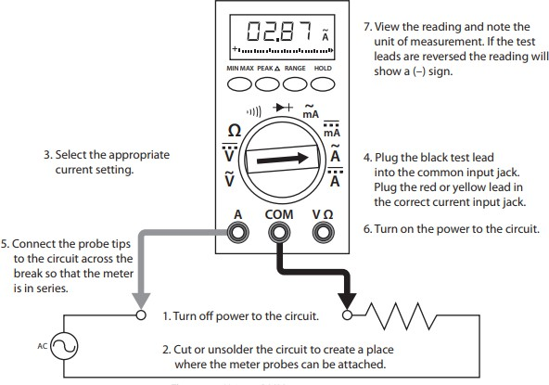

Figure 4 Using a DMM to measure current

Lab Tasks:

  - Measure Current between R1 and R2, and Voltage across R1, R2.
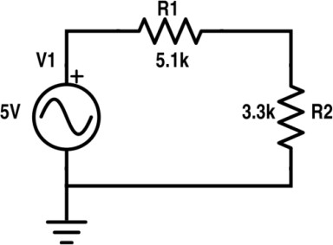

Practical Values:

R1 Voltage | R2 Voltage | Current
3.03V | 1.96V | 0.59mA
Theoretical Values:

R1 Voltage | R2 Voltage | Current
3V | 1.95V | 0.6mA

  - Measure Current at node 2 and 3 and Voltage across R1, R2, R3.

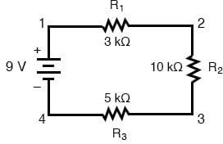

Practical Values:

R1 Voltage | R2 Voltage | R3 Voltage | Current at node 2 | Current at node 3
1.5V | 5V | 2.5V | 0.5mA | 0.5mA

Theoretical Values:

R1 Voltage | R2 Voltage | R3 Voltage | Current at node 2 | Current at node 3
1.5V | 5V | 2.5V | 0.5mA | 0.5mA

Post Lab Questions:

1. Define energy.
Energy is the capacity or ability of a physical system to perform work. In an electrical context, it is the total amount of work done by an electric current over a specific period. It is measured in Joules (J) or kilowatt-hours (kWh).
2. Define power.
Power is the rate at which work is performed or the rate at which energy is consumed or transferred per unit of time. In electronics, it is calculated as the product of voltage and current ($P = V \times I$). The standard unit of measurement for power is the Watt (W).
3. What is charge?
Charge is a fundamental physical property of matter that causes it to experience a force when placed in an electromagnetic field. It exists in two types, positive and negative, typically carried by protons and electrons. The SI unit for electric charge is the Coulomb (C).
4. What is circuit?
A circuit is a closed-loop path through which electric current can flow to perform a specific task. It typically consists of a power source, conducting wires, and various components like resistors or capacitors. For current to flow, the path must be continuous without any breaks.
5. What is the role of a resistor in the series circuit?
In a series circuit, a resistor’s primary role is to limit or regulate the flow of electrical current to a safe level. It also creates a specific voltage drop across itself, which helps in distributing the total source voltage among components. Because it is in series, it affects the total resistance of the entire loop.
6. What is the voltage divider rule?
The voltage divider rule is a formula used to calculate the voltage drop across a specific resistor in a series circuit. it states that the voltage across a resistor is proportional to its resistance relative to the total resistance of the circuit.
7. What are the features of the series circuit?
A series circuit features a single path for current, meaning the current remains identical through all components. The total resistance is the sum of all individual resistances, and the total source voltage is divided among the components. If one component fails or the path is broken, the entire circuit stops functioning.
8. Differentiate between the internal circuit of voltmeter and ammeter.
A voltmeter is designed with a very high internal resistance to ensure it doesn't draw significant current from the circuit it is measuring. Conversely, an ammeter is designed with a very low internal resistance to allow current to pass through it without altering the circuit's behavior. This difference ensures that the measurement process does not interfere with the actual circuit values.
9. In which combination we connect DMM to measure current and voltages.
To measure voltage, the Digital Multimeter (DMM) is connected in parallel across the component to capture the potential difference. To measure current, the DMM must be connected in series within the circuit path so that the total current flows through the meter. Incorrectly connecting an ammeter in parallel can lead to a short circuit and damage the meter.

